Homepage order

- Hero
- Client logos
- One liner
- Marketing/IT
- Stats
- Features
- Testimonials
- Integrations
- CTA

General notes

I would move the testimonials up as I have suggested in the module order and also make the text larger. I think they’re important and lost at the very bottom

To confirm there is currently no mention of resellers on the homepage

I would remove all the button style tags on the page as I don’t feel they add much eg ‘AI powered wifi marketing’ at the top (apart from on Marketing/IT section)

Currently all the subheaders are in light grey which doesn’t provide enough contrast to the white background. I’d go with a darker colour like the header

I haven’t mentioned that you’re very flexible and often do customisations for free as it’s hard to define and might set an expectation that you will do lots of free work

To flag you should go through automated emails, brochure and rest of site after we complete this to make sure the messaging and any stats are consistent

[HOME PAGE]

[hero module]
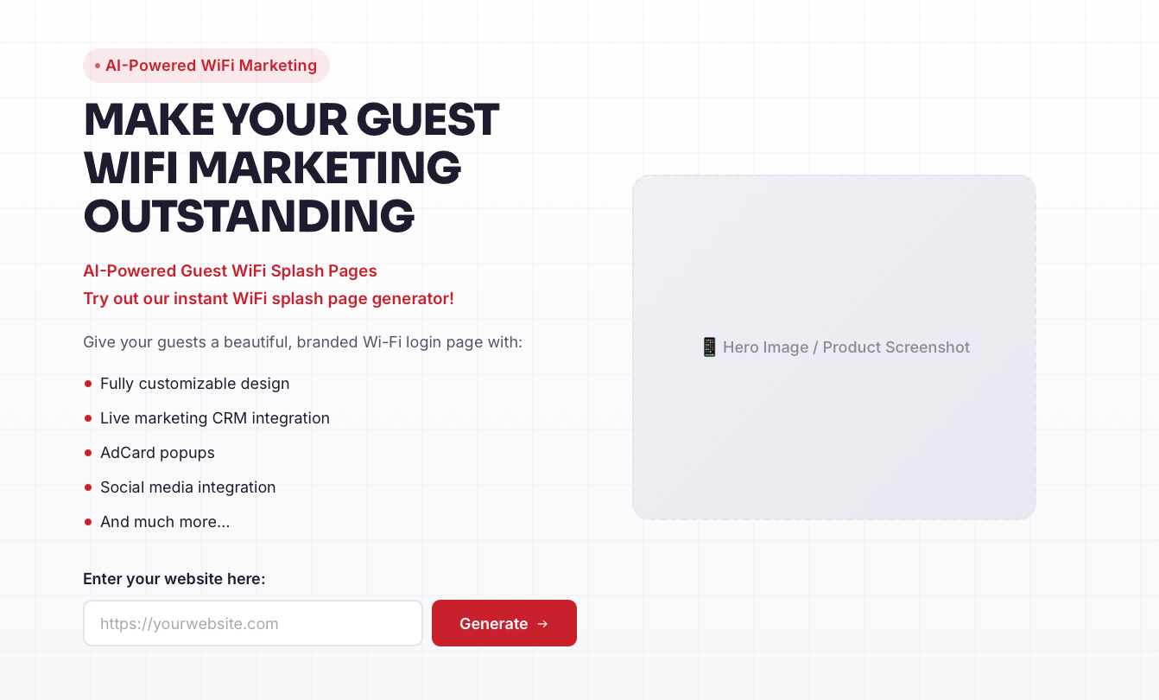

[header]
The guest WiFi platform that turns your customers into superfans
[body copy]
Turn your WiFi into a powerful marketing tool that brings customers back. Built by nice people who care.
Create your branded WiFi login page in under 10 seconds.
[Primary CTA]
Copy: Enter your website to see your page (make font same size as body copy).
Page generator URL entry box: yourwebsite.com (does it need the https? If not then cut)
Page generator CTA button: Create my page

[Secondary CTA]
Copy: Just want to see our brochure?
Button: Download our brochure
Notes
- Remove AI powered button at top and mentioning AI powered

[client logos]
[Copy above logos]
Trusted by:

Notes
- Would give a bit more white padding on either side of the logos as it looks quite cramped and would make the logos bigger

[One liner]

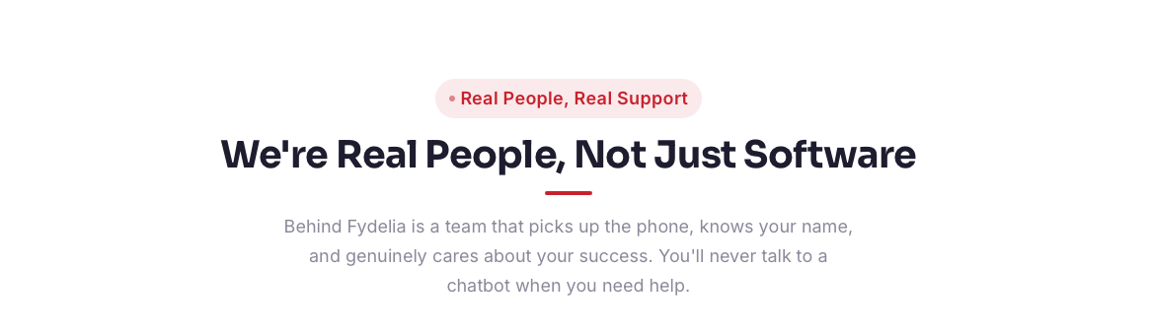
[header + subhead]
Get outstanding support from hospitality loving humans
We’re nice people who respond fast and treat your problems as our own. No long term contracts or hidden fees.
Notes
- Remove the real people button at top
- Cut the 3 boxes underneath

[Marketing/IT]
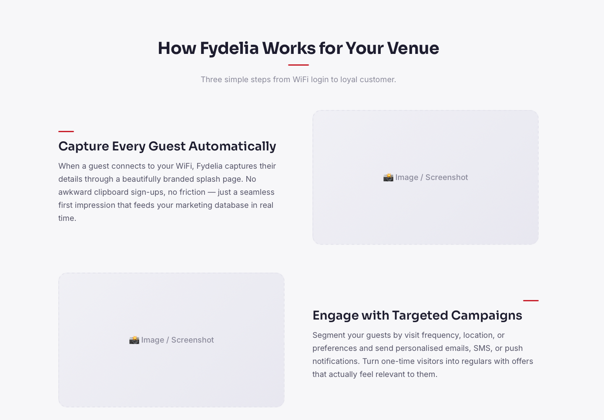

[header + subhead]
Marketing & IT teams - we’ve got you covered
A reliable, user-friendly platform that just works
[marketing - replace red line with red button above subheader ]
For Marketing Teams
[marketing header]
Built to grow sales
[body copy]
You want WiFi that makes it easy for your guests to opt-in and different ways to keep reaching them. Customer data flows straight to your favourite CRM with no issues. Easy to use tools increase your guest spend.
[IT - replace red line with red button above subheader ]
For IT Teams
[IT header]
Built to set and forget
[body copy]
You want guest WiFi that works with your existing hardware and doesn't flood you with tickets. Fast to setup and runs without issues. If you need our support we respond fast.
Notes
- Could add a reliability stat to the IT part.

[Stats]
[header]
More than just email sign ups
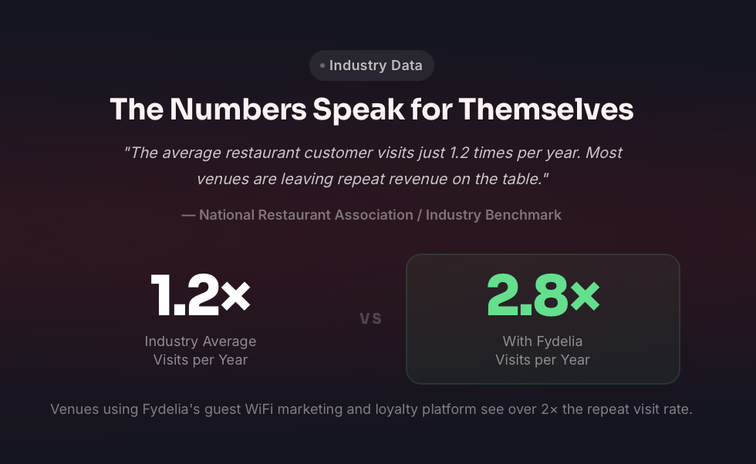
Notes
- Remove button at top
- Remove quote
- Remove line at bottom ‘Venues using…’
- Any more stats to add to the module or elsewhere on the page eg repeat visits and opt-in rates?
[Features]
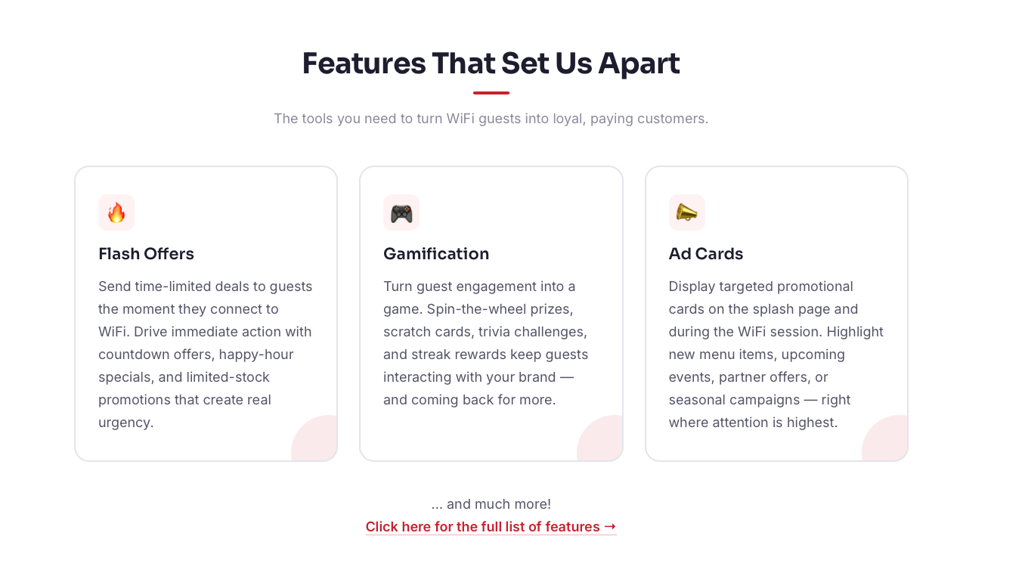

[header + subhead]
Features that bring guests back
Simple to set up and keep your guests engaged and spending more. Most WiFi providers stop at data capture. We're just getting started.
[flash offers header]
Flash Offers/Smart Offers
[body copy]
Recognise returning guests and trigger offers based on how often they visit, what time they arrive and more. Give regulars a reason to return sooner and spend more.
[gamification header]
Gamification/Guest games
Turn WiFi sign-up into fun brand experiences. Scratch cards, spin-to-win and other games that make guests want to sign up.
[Ad cards header]
Ad Cards/Promo cards
Promote new menu items, upcoming events and seasonal offers on great looking branded cards. Set up in minutes and perfect for impulse purchases.
[bottom of module copy]
See all our features [LINK TO FEATURES PAGE]

Notes
- I have suggested new names for the cards - if we went for that it would need to be updated everywhere (features page, email, brochure).

[Integrations]
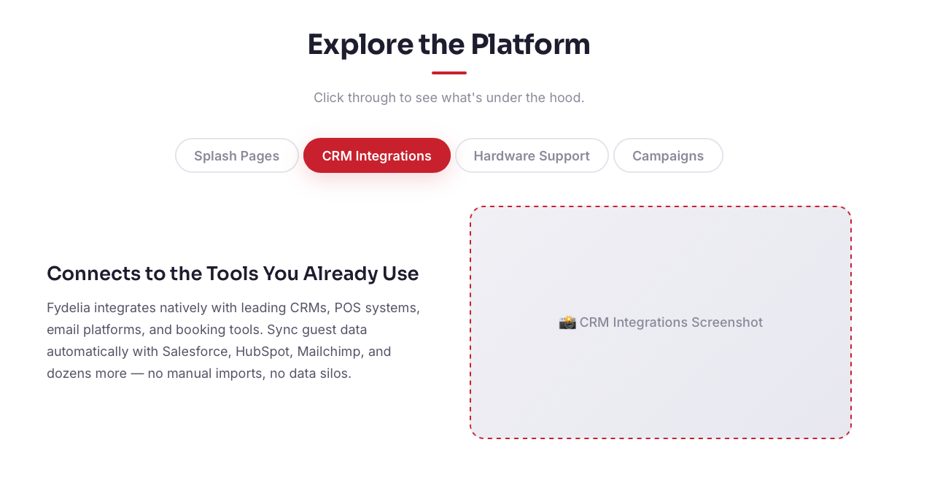
[header + subhead]
Plugs straight in
Direct integrations with your existing CRM and hardware that work immediately.

[CRM tab]
CRM Integrations
[header]
Works with your favourite CRM
[body copy]
Direct integrations with all the major CRM platforms, working from day one. We check your CRM first before asking guests anything so returning guests get logged in straight away.
[Hardward tab]
Hardware Integrations
[header]
No new hardware needed
[body copy]
Works with your existing hardware with no extra charges for venues with multiple devices. Quick to setup and full remote management mean you just leave it with us to run smoothly.

Notes
- I haven’t listed the CRMs or hardware names as the screenshot should be the logos
[CTA]
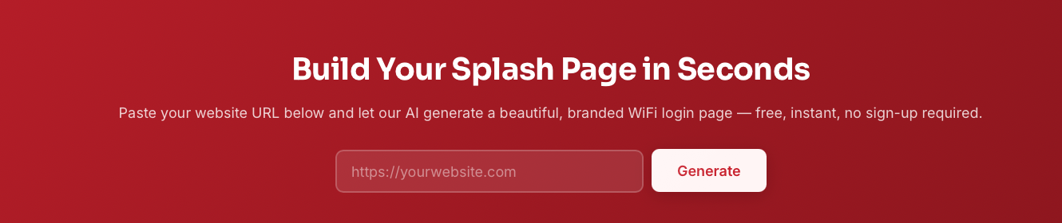
[header]
Start your free trial
[body copy]
Enter your website and we'll create your branded WiFi login page in seconds. Like what you see? Try it live in your venue - free for 14 days.
[CTA]
Page generator URL entry box: yourwebsite.com (does it need the https? If not then cut)
Page generator CTA button: See my page

